**“**All power is within you; you can do anything and everything”

*-Swami Vivekananda*

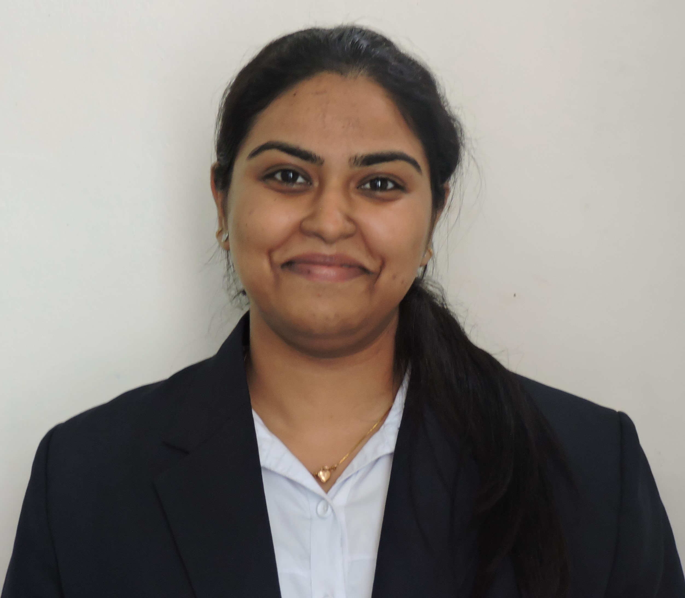

**SKILLS**

* ORGANIZED
* HARDWORKING
* RESPONSIBLE
* MS OFFICE

|  |  |  |  |  |
| --- | --- | --- | --- | --- |
| **ACADEMIC QUALIFICATION** | **QUALIFICATION** | **INSTITUTION** | **YEAR OF PASSING** | **PERCENTAGE/**  **CGPA** |
| PGDM | Pune Institute Of Business Management, Pune | Pursuing | N/A |
| B.Com(H) | TSR & TBK Degree College | 2014 | 7.64  (CGPA) |
| 12th | Hijli High School | 2011 | 66% |
| 10th | Hijli High School | 2009 | 73% |

**gn**

|  |  |  |
| --- | --- | --- |
| WINTER INTERSHIP | Kalpataru Real Estate  (Project time-42Days) | **Project Title** “Channel Partner Feedback on Virtual Reality as a marketing tool”  **Objective**: To analyze whether the sales would be increased through the walk ins.  **Procedure**:   * Designed questionnaire to grab the response from the Channel partners. * Cold calling to more than 35 channel partners to achieve their feedback. * Analyzing the data collected (as per the sales of the product)   **Project Title** “Study Report on Consumers response to the campaign “Building your dream home”  **Objective**: To help the company for the new housing project at Pimple (Nilakh) i.e. in pricing, amenities, quality and the market.  **Procedure**:   * Designed questionnaire consisting of 45 questions. * Cold calling and meeting more than 35 channel partners for their feedback. * Analyzing the data collected * Creating the report as per the feedback * Provided ideas to the company related to the product development in each micro markets of Pune. |

|  |  |  |  |  |
| --- | --- | --- | --- | --- |
| **WORK**  **EXPERIENCE** | **Company** | **Designation** | **Duration** | **Responsibilities** |
| Genpact (Hyderabad)  (Recovery & Process Training) | Process Associate | 12 months | **Process Associate**   * To reduce client credibility in the market. * Analysis the data given by the client. * Achieving the targets by recovering the money from the customers through calls. * Giving customer information about the client’s financial products.   **Process Trainer**   * Training the new joinees in the process. * Evaluating the call taken by the associates. * Giving feedback to the associates. |

|  |  |  |
| --- | --- | --- |
| **ACTIVITIES** | **CO-CURRICULAR** | * Done presentation for different case study(TiVo, Hilton, Ciba, Himalaya) * Sector Analysis on Tourism sector in India. * Participated in NIPM seminar at Pune. * Attended World HRD conference Mumbai 2017. * Did a detailed analysis on Vishakha Dairy (Vishakhapatnam). * Industrial visit at Coca Cola, Mapro, Videocon. |
| **EXTRA**  **CURRICULAR** | * Best employee of the month award from Genpact * Multiple certificates in cultural and sports competitions. * Distinction holder in dance (Rabindra Nritya & Kathak) & painting. * Member of Mountaineer Club Kharagpur. * Won 2nd Prize in seminar organized in college. * Organized sports tournaments, blood donations camps and cultural events at school and college. * Arranged Farewell for seniors in college 2013. * Arranged school Golden Jubilee celebration and cultural fest for 3 days * Food committee and Media club member at PIBM * Member of college placement committee. |

**DECLARATION**

I do hereby declare that the afore-mentioned information is correct up to the best of my knowledge and I bear the responsibility for the authenticity of the data provided.

D:\documents\scan0005.jpg

_____________

Signature